Englisch als Vertragssprache |500.094 | Students‘ name: Max Riese

# US Presidential Election System

## Have a look here: <http://kleinerriese.github.io/us_election/>

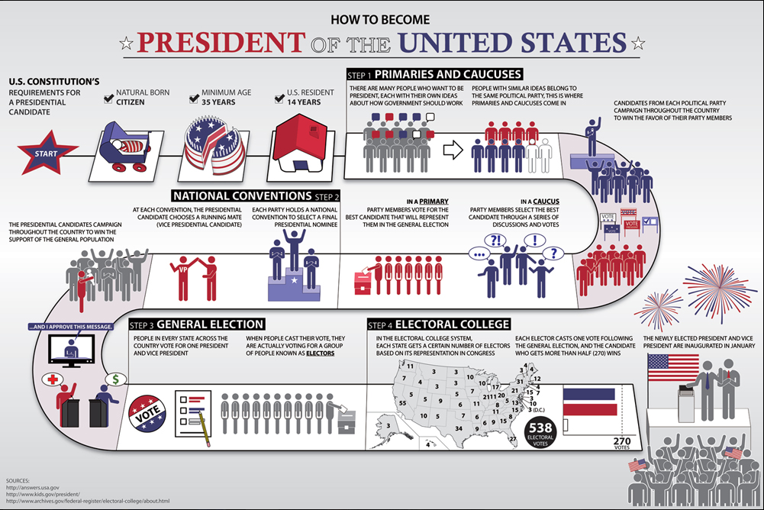

## Vocabulary

|  |  |  |
| --- | --- | --- |
| Term | English/English | (German) |
| constitution | a set of fundamental principles or established precedents according to which a state or other organization is governed. | Verfassung |
| Electoral collage | (in the US) a body of people representing the states of the US, who formally cast votes for the election of the president and vice president. | Wahlkollegium |
| caucuses | a meeting of the members of a legislative body who are members of a particular political party, to select candidates or decide policy. | Wahlausschuss |
| Convention | usually suggests a meeting of delegates representing political, church, social, or fraternal organizations | Konvention, Congress |